Internship Project
Report

Title: HR Attrition Analysis

Internship Domain: Data Analyst

Tools Used: Python (pandas, seaborn, scikit-learn), Excel,
Jupyter Notebook

Submitted by – Ranjeet Singh

Table of Contents

- Introduction
- Data Cleaning & Preparation
- Exploratory Data Analysis
- Predictive Modeling
- Categorical Insights
- Key Takeaways
- Learning Outcomes
- Conclusion

Introduction

- Source: HR Employee Attrition dataset
- Rows: 1,470 employees
- Columns: 35 features including demographics, compensation, tenure, satisfaction scores, and attrition status
- Target Variable: Attrition (Yes/No), converted to AttritionFlag (1/0)
Data Cleaning & Preparation
- Verified no missing or duplicate data
- Converted categorical variables (e.g., OverTime) to binary flags
- Created new features:
  - OverTimeFlag: 1 if employee works overtime
  - AttritionFlag: 1 if employee left
  - Scaled numeric features using StandardScaler for modeling
Exploratory Data Analysis
Attrition Distribution
- 16.1% of employees left the company
- Visualized using bar and pie charts for clarity
Department-Level Attrition
- Highest attrition in Sales
- Lowest in Research & Development
Income vs Attrition
- Employees who left had significantly lower monthly income
- Shown via boxplot and violin plot
Overtime Impact
- Employees working overtime had much higher attrition rates
- Strong visual separation in bar chart
Satisfaction Scores
- Lower scores in Environment, Job, Relationship, and Work-Life Balance correlated with higher attrition
- Countplots revealed clear patterns
Correlation Matrix
- Strong negative correlation between attrition and:
  - Monthly Income
  - Years at Company
  - Total Working Years
Predictive Modeling
Model 1: Logistic Regression
- Accuracy: 85.0%
- ROC AUC: 0.75
- Confusion Matrix:
  - True Positives: 11
  - False Negatives: 60
  - True Negatives: 364
  - False Positives: 6
Model 2: Random Forest Classifier
- Trained with 100 estimators
- Feature Importance:
  - MonthlyIncome (most important)
  - TotalWorkingYears
  - YearsAtCompany
  - OverTimeFlag
  - DistanceFromHome
Categorical Insights
Category | Insight
Gender | Slightly higher attrition among females
Marital Status | Singles had highest attrition; married employees more stable
Education Field | HR and Technical degrees showed higher attrition
Business Travel | Frequent travelers had highest attrition
Department | Sales department had highest turnover

Key Takeaways
- Compensation is the strongest attrition driver
- Overtime and commute distance contribute significantly to turnover
- Tenure and promotion history are protective factors
- Sales and HR departments need targeted retention strategies

Learning Outcomes
- Applied end-to-end data science workflow
- Practiced feature engineering and model evaluation
- Learned to communicate insights visually and statistically
- Gained experience in stakeholder-ready reporting
- Strengthened understanding of HR analytics and employee behavior

Conclusion
This project provided a comprehensive view of employee attrition patterns and their underlying causes. By combining statistical analysis with machine learning, I identified key drivers such as income, overtime, and tenure. The insights generated can help HR teams proactively address retention risks and improve workforce stability. This internship deepened my skills in data storytelling, model building, and stakeholder communication — and prepared me for real-world analytics challenges.

Code with Output
import pandas as pd
import numpy as np
import matplotlib.pyplot as plt
import seaborn as sns
# 1.2 Load the dataset
df = pd.read_csv('HR-Employee-Attrition.csv')
df.head()
Age Attrition BusinessTravel DailyRate Department \
0 41 Yes Travel_Rarely 1102 Sales
1 49 No Travel_Frequently 279 Research & Development
2 37 Yes Travel_Rarely 1373 Research & Development
3 33 No Travel_Frequently 1392 Research & Development
4 27 No Travel_Rarely 591 Research & Development
DistanceFromHome Education EducationField EmployeeCount EmployeeNumber \
0 1 2 Life Sciences 1 1
1 8 1 Life Sciences 1 2
2 2 2 Other 1 4
3 3 4 Life Sciences 1 5
4 2 1 Medical 1 7
... RelationshipSatisfaction StandardHours StockOptionLevel \
0 ... 1 80 0
1 ... 4 80 1
2 ... 2 80 0
3 ... 3 80 0
4 ... 4 80 1
TotalWorkingYears TrainingTimesLastYear WorkLifeBalance YearsAtCompany \
0 8 0 1 6
1 10 3 3 10
2 7 3 3 0
3 8 3 3 8
4 6 3 3 2
YearsInCurrentRole YearsSinceLastPromotion YearsWithCurrManager
0 4 0 5
1 7 1 7
2 0 0 0
3 7 3 0
4 2 2 2
[5 rows x 35 columns]
print(f"Rows: {df.shape[0]}, Columns: {df.shape[1]}")
df.info()
import warnings
warnings.filterwarnings('ignore')
Rows: 1470, Columns: 35
<class 'pandas.core.frame.DataFrame'>
RangeIndex: 1470 entries, 0 to 1469
Data columns (total 35 columns):
# Column Non-Null Count Dtype
--- ------ -------------- -----
0 Age 1470 non-null int64
1 Attrition 1470 non-null object
2 BusinessTravel 1470 non-null object
3 DailyRate 1470 non-null int64
4 Department 1470 non-null object
5 DistanceFromHome 1470 non-null int64
6 Education 1470 non-null int64
7 EducationField 1470 non-null object
8 EmployeeCount 1470 non-null int64
9 EmployeeNumber 1470 non-null int64
10 EnvironmentSatisfaction 1470 non-null int64
11 Gender 1470 non-null object
12 HourlyRate 1470 non-null int64
13 JobInvolvement 1470 non-null int64
14 JobLevel 1470 non-null int64
15 JobRole 1470 non-null object
16 JobSatisfaction 1470 non-null int64
17 MaritalStatus 1470 non-null object
18 MonthlyIncome 1470 non-null int64
19 MonthlyRate 1470 non-null int64
20 NumCompaniesWorked 1470 non-null int64
21 Over18 1470 non-null object
22 OverTime 1470 non-null object
23 PercentSalaryHike 1470 non-null int64
24 PerformanceRating 1470 non-null int64
25 RelationshipSatisfaction 1470 non-null int64
26 StandardHours 1470 non-null int64
27 StockOptionLevel 1470 non-null int64
28 TotalWorkingYears 1470 non-null int64
29 TrainingTimesLastYear 1470 non-null int64
30 WorkLifeBalance 1470 non-null int64
31 YearsAtCompany 1470 non-null int64
32 YearsInCurrentRole 1470 non-null int64
33 YearsSinceLastPromotion 1470 non-null int64
34 YearsWithCurrManager 1470 non-null int64
dtypes: int64(26), object(9)
memory usage: 402.1+ KB
print(f'duplicate data:{df.duplicated().sum()}')
df.isnull().sum()/len(df)
duplicate data:0
Age 0.0
Attrition 0.0
BusinessTravel 0.0
DailyRate 0.0
Department 0.0
DistanceFromHome 0.0
Education 0.0
EducationField 0.0
EmployeeCount 0.0
EmployeeNumber 0.0
EnvironmentSatisfaction 0.0
Gender 0.0
HourlyRate 0.0
JobInvolvement 0.0
JobLevel 0.0
JobRole 0.0
JobSatisfaction 0.0
MaritalStatus 0.0
MonthlyIncome 0.0
MonthlyRate 0.0
NumCompaniesWorked 0.0
Over18 0.0
OverTime 0.0
PercentSalaryHike 0.0
PerformanceRating 0.0
RelationshipSatisfaction 0.0
StandardHours 0.0
StockOptionLevel 0.0
TotalWorkingYears 0.0
TrainingTimesLastYear 0.0
WorkLifeBalance 0.0
YearsAtCompany 0.0
YearsInCurrentRole 0.0
YearsSinceLastPromotion 0.0
YearsWithCurrManager 0.0
dtype: float64
df.describe()
df.head()
Age Attrition BusinessTravel DailyRate Department \
0 41 Yes Travel_Rarely 1102 Sales
1 49 No Travel_Frequently 279 Research & Development
2 37 Yes Travel_Rarely 1373 Research & Development
3 33 No Travel_Frequently 1392 Research & Development
4 27 No Travel_Rarely 591 Research & Development
DistanceFromHome Education EducationField EmployeeCount EmployeeNumber \
0 1 2 Life Sciences 1 1
1 8 1 Life Sciences 1 2
2 2 2 Other 1 4
3 3 4 Life Sciences 1 5
4 2 1 Medical 1 7
... RelationshipSatisfaction StandardHours StockOptionLevel \
0 ... 1 80 0
1 ... 4 80 1
2 ... 2 80 0
3 ... 3 80 0
4 ... 4 80 1
TotalWorkingYears TrainingTimesLastYear WorkLifeBalance YearsAtCompany \
0 8 0 1 6
1 10 3 3 10
2 7 3 3 0
3 8 3 3 8
4 6 3 3 2
YearsInCurrentRole YearsSinceLastPromotion YearsWithCurrManager
0 4 0 5
1 7 1 7
2 0 0 0
3 7 3 0
4 2 2 2
[5 rows x 35 columns]
df['Attrition'].value_counts(normalize=True)
Attrition
No 0.838776
Yes 0.161224
Name: proportion, dtype: float64
import matplotlib.pyplot as plt
#Compute normalized counts
attr_dist = df['Attrition'].value_counts(normalize=True)
#Bar chart of proportions
plt.figure(figsize=(6,4))
attr_dist.plot(kind='bar', color=['skyblue','salmon'])
plt.title('Proportion of Attrition (Yes vs. No)')
plt.ylabel('Proportion')
plt.xticks(rotation=0)
plt.show()
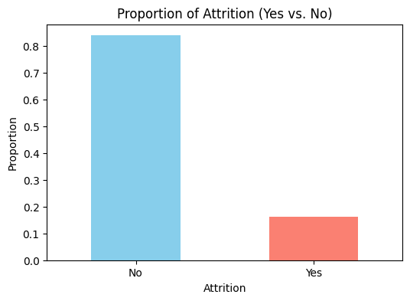
#Pie chart of proportions
plt.figure(figsize=(5,5))
attr_dist.plot(
kind='pie',
autopct='%.1f%%',
startangle=90,
colors=['skyblue','salmon'],
wedgeprops={'edgecolor':'white'}
)
plt.ylabel('') # hide default y-label
plt.title('Attrition Breakdown')
plt.show()
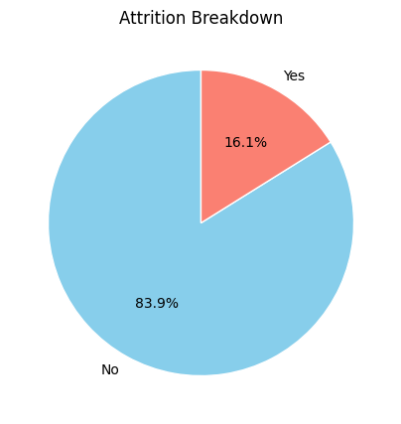
import matplotlib.pyplot as plt
# 1. Inspect current columns
print("Columns in df:", df.columns.tolist())
# 2. Create AttritionFlag if missing
if 'AttritionFlag' not in df.columns:
df['AttritionFlag'] = df['Attrition'].map({'Yes': 1, 'No': 0})
print("Added AttritionFlag. Sample values:\n", df[['Attrition','AttritionFlag']].head())
# 3. Now compute and plot
dept_attr = df.groupby('Department')['AttritionFlag'].mean() * 100
fig, ax = plt.subplots(figsize=(8,4))
dept_attr.sort_values(ascending=False).plot(
kind='bar',
color='salmon',
ax=ax
)
# Labels, title, annotations
ax.set_ylabel('Attrition Rate (%)')
ax.set_title('Attrition % by Department')
for i, pct in enumerate(dept_attr.sort_values(ascending=False)):
ax.text(i, pct + 0.5, f"{pct:.1f}%", ha='center')
plt.xticks(rotation=45, ha='right')
plt.tight_layout()
plt.show()
Columns in df: ['Age', 'Attrition', 'BusinessTravel', 'DailyRate', 'Department', 'DistanceFromHome', 'Education', 'EducationField', 'EmployeeCount', 'EmployeeNumber', 'EnvironmentSatisfaction', 'Gender', 'HourlyRate', 'JobInvolvement', 'JobLevel', 'JobRole', 'JobSatisfaction', 'MaritalStatus', 'MonthlyIncome', 'MonthlyRate', 'NumCompaniesWorked', 'Over18', 'OverTime', 'PercentSalaryHike', 'PerformanceRating', 'RelationshipSatisfaction', 'StandardHours', 'StockOptionLevel', 'TotalWorkingYears', 'TrainingTimesLastYear', 'WorkLifeBalance', 'YearsAtCompany', 'YearsInCurrentRole', 'YearsSinceLastPromotion', 'YearsWithCurrManager']
Added AttritionFlag. Sample values:
Attrition AttritionFlag
0 Yes 1
1 No 0
2 Yes 1
3 No 0
4 No 0
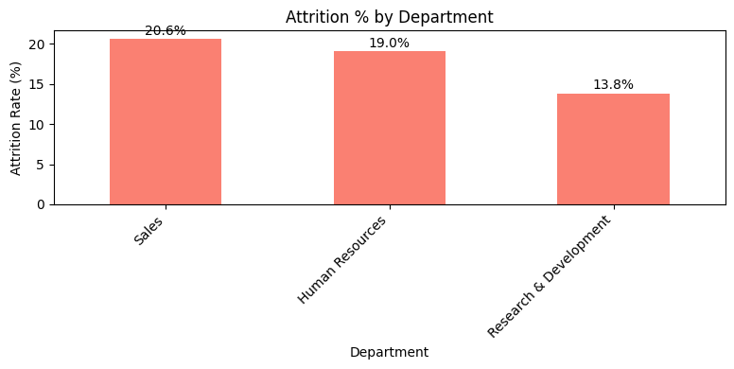
dept_attr2 = (
df.groupby('Department')['Attrition']
.apply(lambda x: (x=='Yes').mean()*100)
)
dept_attr2.plot(kind='bar', color='salmon', figsize=(8,4), rot=45)
plt.ylabel('Attrition Rate (%)')
plt.title('Attrition % by Department')
plt.show()
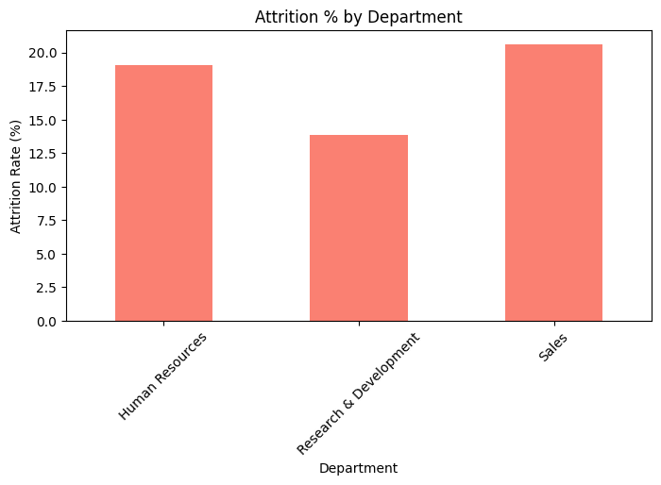
plt.figure(figsize=(6,4))
sns.violinplot(x='Attrition', y='MonthlyIncome', data=df, palette='pastel')
plt.title('Income Distribution by Attrition')
plt.show()
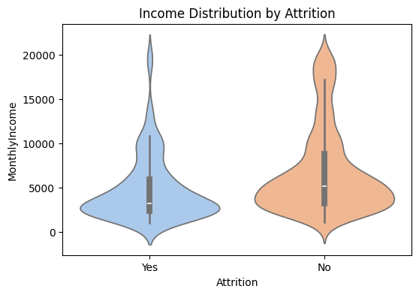
plt.figure(figsize=(6,4))
sns.barplot(x='OverTime', y='AttritionFlag', data=df, palette='magma')
plt.ylabel('Attrition Rate')
plt.title('Attrition vs. Overtime')
plt.show()
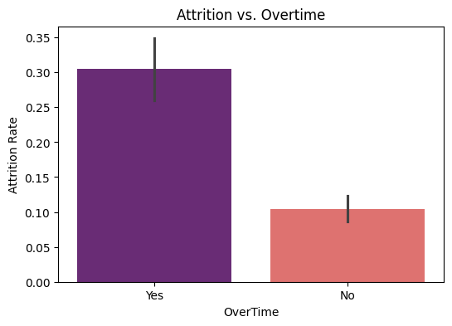
sats = ['EnvironmentSatisfaction','JobSatisfaction','WorkLifeBalance','RelationshipSatisfaction']
fig, axes = plt.subplots(2, 2, figsize=(10,8))
for col, ax in zip(sats, axes.flatten()):
sns.countplot(x=col, hue='Attrition', data=df, ax=ax, palette='Set2')
ax.set_title(col)
ax.legend(title='Attrition')
plt.tight_layout()
plt.show()
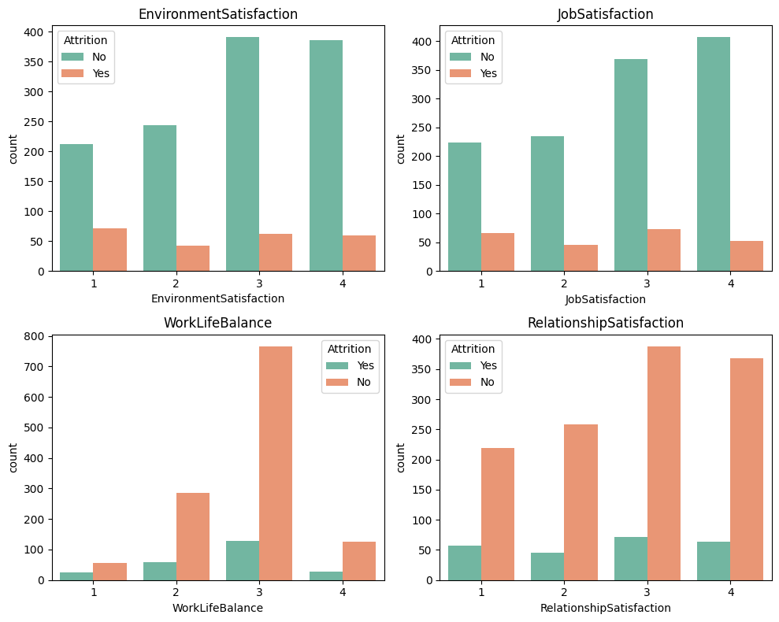
# Select numerical columns
num_cols = ['Age','DistanceFromHome','MonthlyIncome','NumCompaniesWorked',
'PercentSalaryHike','TotalWorkingYears','YearsAtCompany']
corr = df[num_cols + ['AttritionFlag']].corr()
plt.figure(figsize=(8,6))
sns.heatmap(corr, annot=True, cmap='coolwarm', fmt=".2f")
plt.title('Correlation Matrix')
plt.show()
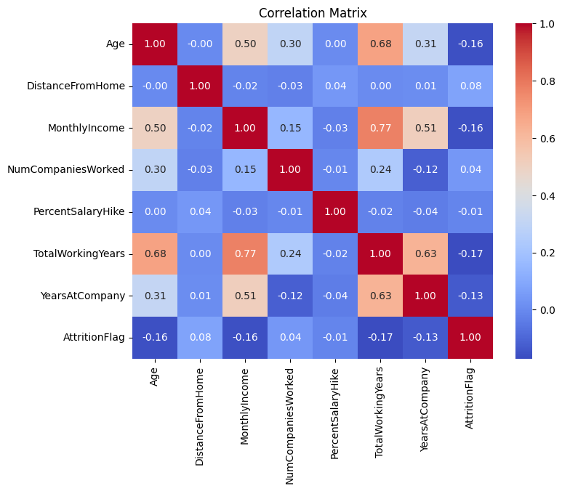
from sklearn.model_selection import train_test_split
from sklearn.preprocessing import OneHotEncoder, StandardScaler
# 7.1.1 Select features
features = ['Age','DistanceFromHome','MonthlyIncome','NumCompaniesWorked',
'PercentSalaryHike','TotalWorkingYears','YearsAtCompany','OverTime']
X = df[features].copy()
# 7.1.2 Encode Overtime and scale
X['OverTimeFlag'] = (X['OverTime']=='Yes').astype(int)
X.drop(columns='OverTime', inplace=True)
scaler = StandardScaler()
X_scaled = scaler.fit_transform(X)
y = df['AttritionFlag']
# 7.1.3 Split
X_train, X_test, y_train, y_test = train_test_split(
X_scaled, y, test_size=0.3, random_state=42, stratify=y
)
from sklearn.linear_model import LogisticRegression
from sklearn.metrics import accuracy_score, roc_auc_score, confusion_matrix
model = LogisticRegression()
model.fit(X_train, y_train)
y_pred = model.predict(X_test)
y_prob = model.predict_proba(X_test)[:,1]
print("Accuracy:", accuracy_score(y_test, y_pred))
print("ROC AUC:", roc_auc_score(y_test, y_prob))
print("Confusion Matrix:\n", confusion_matrix(y_test, y_pred))
Accuracy: 0.8503401360544217
ROC AUC: 0.7469356680624285
Confusion Matrix:
[[364 6]
[ 60 11]]
from sklearn.ensemble import RandomForestClassifier
rf = RandomForestClassifier(n_estimators=100, random_state=42)
rf.fit(X_train, y_train)
importances = pd.Series(rf.feature_importances_, index=X.columns)
importances.sort_values().plot(kind='barh', figsize=(6,4), color='teal')
plt.title('Feature Importance')
plt.show()
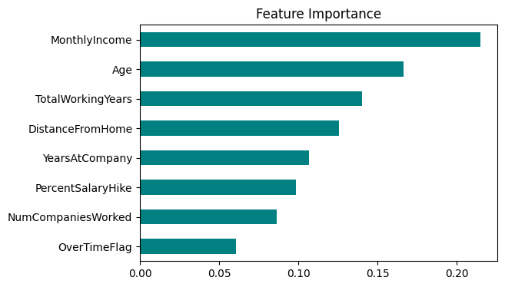
import matplotlib.pyplot as plt
import seaborn as sns
plt.figure(figsize=(8,4))
sns.histplot(
df['MonthlyIncome'],
bins=30,
kde=True,
color='steelblue'
)
plt.title('Distribution of Monthly Income')
plt.xlabel('Monthly Income')
plt.ylabel('Count')
plt.tight_layout()
plt.show()
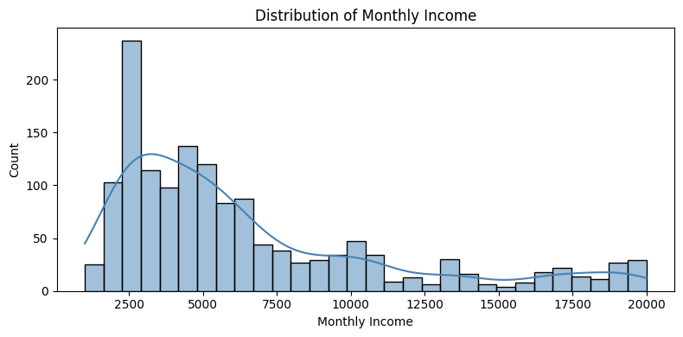
plt.figure(figsize=(6,4))
sns.boxplot(
x='Attrition',
y='MonthlyIncome',
data=df,
palette=['lightgreen','salmon']
)
plt.title('Monthly Income by Attrition Status')
plt.xlabel('Attrition')
plt.ylabel('Monthly Income')
plt.tight_layout()
plt.show()
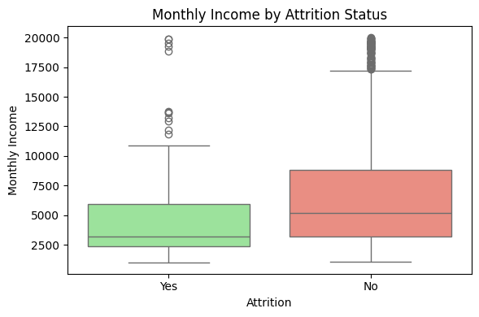
plt.figure(figsize=(6,4))
sns.violinplot(
x='Attrition',
y='MonthlyIncome',
data=df,
inner='quartile',
palette=['lightblue','lightcoral']
)
plt.title('Income Distribution by Attrition')
plt.xlabel('Attrition')
plt.ylabel('Monthly Income')
plt.tight_layout()
plt.show()
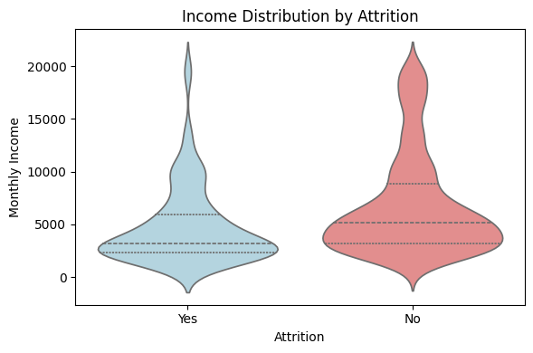
#Ensure AttritionFlag exists
if 'AttritionFlag' not in df.columns:
df['AttritionFlag'] = df['Attrition'].map({'Yes':1, 'No':0})
def plot_attrition_by(col, figsize=(6,4), palette='viridis', order=None):
rates = df.groupby(col)['AttritionFlag'].mean().mul(100)
if order:
rates = rates.reindex(order)
fig, ax = plt.subplots(figsize=figsize)
rates.plot(kind='bar', color=sns.color_palette(palette, len(rates)), ax=ax)
ax.set_ylabel('Attrition Rate (%)')
ax.set_title(f'Attrition % by {col}')
ax.set_ylim(0, rates.max() + 5)
for i, pct in enumerate(rates):
ax.text(i, pct + 0.5, f"{pct:.1f}%", ha='center')
plt.xticks(rotation=45, ha='right')
plt.tight_layout()
plt.show()
#Gender
plot_attrition_by('Gender', palette='pastel')
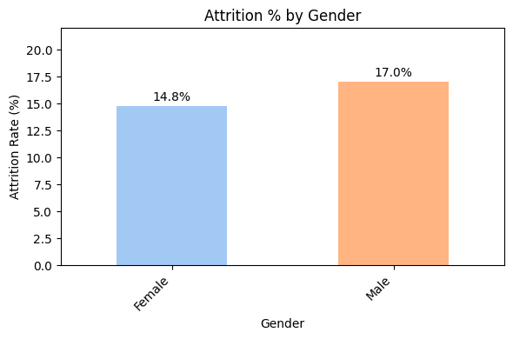
#Marital Status
plot_attrition_by('MaritalStatus', palette='Set2', order=['Single','Married','Divorced'])
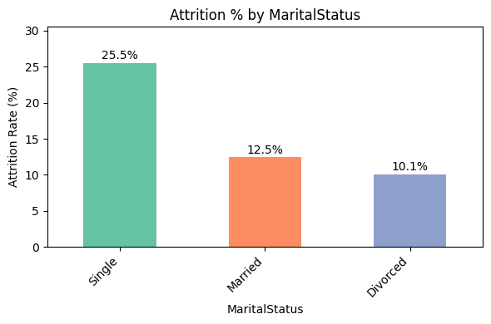
#Education Field
plot_attrition_by('EducationField', palette='cubehelix')
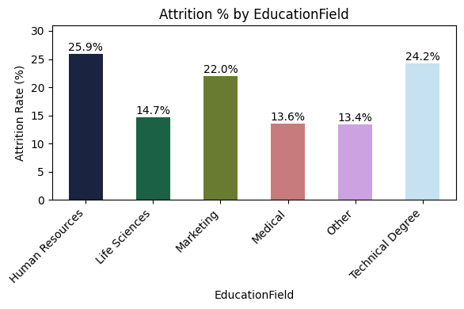
#Business Travel
plot_attrition_by('BusinessTravel', palette='magma',
order=['Non-Travel','Travel_Rarely','Travel_Frequently'])
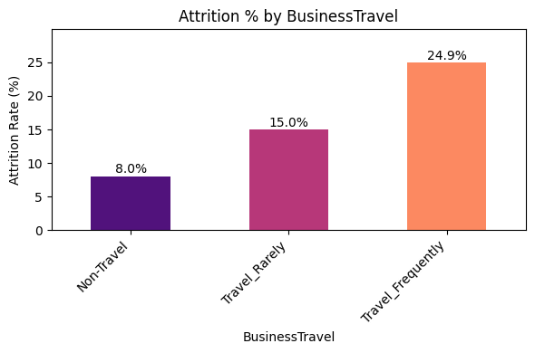
#Department
plot_attrition_by('Department', palette='coolwarm')
